Project Design Phase-II
Technology Stack (Architecture & Stack)
Date | 20 January 2026
Team ID | LTVIP2026TMIDS76912
Project Name | HematoVision: Advanced Blood Cell Classification Using Transfer Learning
Maximum Marks | 4 Marks

Technical Architecture:
The technical architecture of HematoVision consists of a deep learning-based blood cell classification model built using transfer learning with a pre-trained CNN such as VGG16 or ResNet. The dataset is preprocessed and augmented before being split into training and testing sets for model development and evaluation. The trained model is saved and integrated into a Flask web application, where users can upload blood cell images through a simple HTML interface. The Flask backend processes the image, sends it to the model for prediction, and displays the classification result along with confidence scores on the user interface.

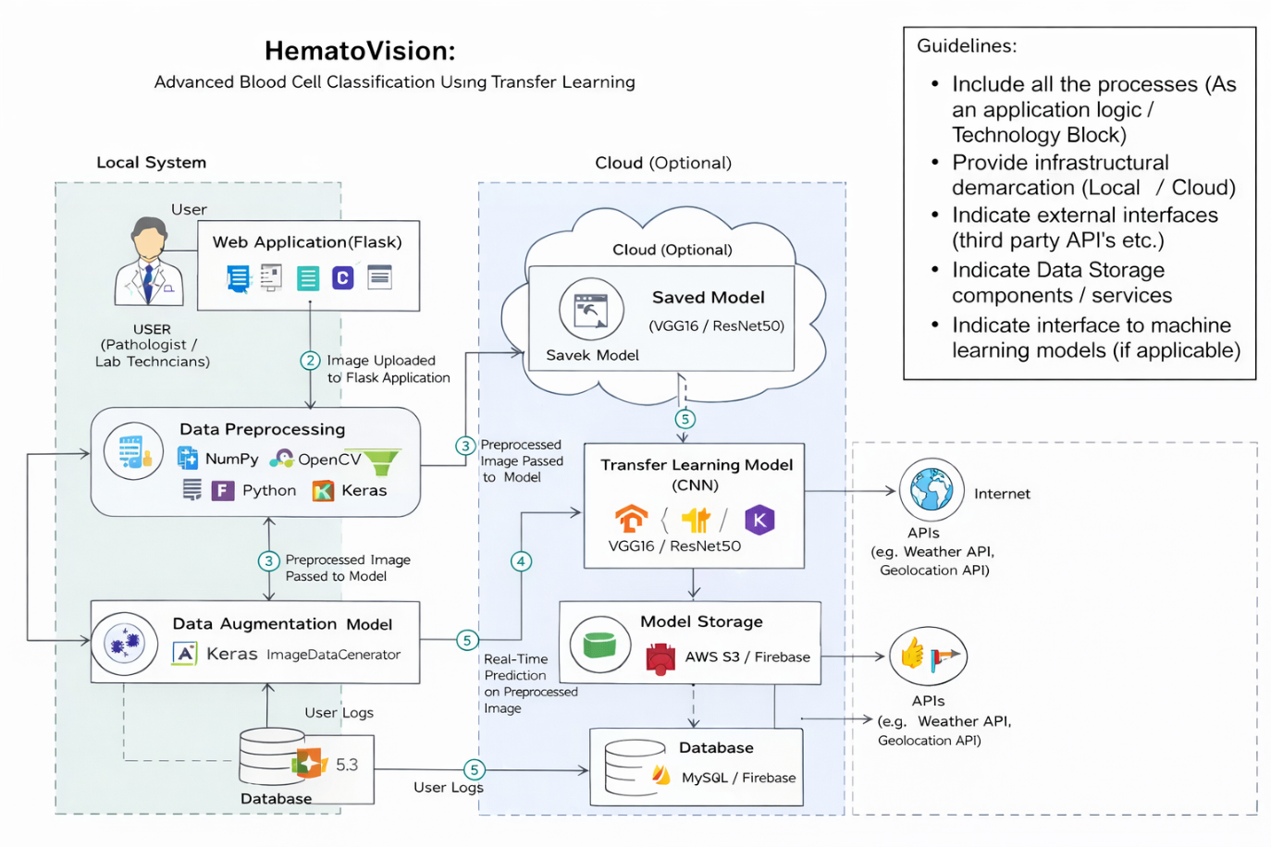

Table-1 : Components & Technologies:
S.No | Component | Description | Technology
 | User Interface | Allows users (pathologists / students) to upload blood cell images and view prediction results | HTML, CSS
 | Web Application Framework | Handles routing, image upload, model invocation, and result display | Python Flask
 | Data Preprocessing Module | Image resizing, normalization, noise removal, and transformation before model input | NumPy, OpenCV, TensorFlow/Keras preprocessing
 | Data Augmentation Module | Enhances dataset diversity to reduce overfitting | Keras ImageDataGenerator
 | Transfer Learning Model | Data Type, Pre-trained CNN adapted for blood cell classificationetc. | VGG16 / ResNet50 (TensorFlow / Keras / PyTorch)
 |  | Training, fine-tuning layers, loss calculation, optimizer selection | Adam Optimizer, Categorical Crossentropy.
  Model Training & Optimization
 | Model Evaluation | Accuracy, confusion matrix, precision, recall, F1-score | Scikit-learn, Matplotlib
 |  | Loads saved model and performs real-time prediction | Flask + TensorFlow
  Backend Integration
 | Model Storage | Saves trained model for deployment | H5 format / SavedModel format

Table-2: Application Characteristics:
S.No | Characteristics | Description | Technology
 | Open-Source Frameworks | Deep learning framework for model development, transfer learning implementation, data preprocessing, visualization, and web deployment | TensorFlow / Keras, PyTorch (optional), Flask, NumPy, OpenCV, Scikit-learn, Matplotlib
 | Security Implementations | Secure image upload validation, input sanitization, restricted file formats (JPG/PNG), prevention of code injection, secure model access, hashed credentials (if login added), HTTPS deployment | Flask Security Features, Werkzeug (Password Hashing – SHA-256), Input Validation, SSL/HTTPS, OWASP Security Practices

